

**FINAL YEAR PROJECT (2020/2021)**

**PROJECT TITLE: CHATBOT SYSTEM**

**A PROJECT REPORT SUBMITTED AS PARTIAL FULFILLMENT OF REQUIREMENTS FOR THE BACHELOR OF SCIENCE IN COMPUTER SCIENCE OF RONGO UNIVERSITY BY**

**NDETI AUGASTINE MULU,**

**OF ADM NO: CSC/003/2017,**

**SCHOOL OF SCIENCE TECHNOLOGY AND ENGINEERING, IN THE DEPARTMENT OF MATHEMATICS AND COMPUTER SCIENCE, FOR THE COURSE**

**COM 423 (COMPUTER SCIENCE PROJECT II).**

**EMAIL: augastinendeti@gmail.com**

# DECLARATION

I, Ndeti Augastine Mulu, of Admission number CSC/003/2017, declare that this project, as presented in this report, is my original work and has not been presented for any other University award.

Signature: …………………….

Date: …………………….

This project has been submitted as partial fulfillment of requirements for the Bachelor of Science in Computer Science of Rongo University with my approval as the University supervisor.

Supervisor’s name: Dr. Charles O. Oguk, PhD, MSc, MBA

Supervisor’s signature: …………………………………………………

Date: ………………………………………………….

# ABSTRACT

This project presents the History, Technology, and Applications of chatbots. It aims to organize critical information that is a necessary background for further research activity in the field of chatbots. More specifically, while giving the historical evolution, from the generative idea to the present day, I point out possible weaknesses of each stage. Moreover, I composed a general architectural design that gathers critical details, and highlighted crucial issues to take into account before the system design. Furthermore, I present chatbots applications and industrial use cases. Finally, I conclude by stating my view regarding the direction of technology, so that chatbots will become really smart.

**Table of Contents**

DECLARATION ii

ABSTRACT iii

**CHAPTER ONE:** 1

**INTRODUCTION** 1

**CHAPTER TWO:** 2

**LITERATURE REVIEW** 2

2.1: Types of chatbots 2

2.2: Previous works in the development of chatbots 2

**CHAPTER THREE:** 7

**METHODOLOGY** 7

3.1: System Analysis 7

*User Interface Component:* 7

*User Message Analysis Component****:*** 7

*Ambiguity Handling:* 7

*Data Handling:* 7

3.2: System Design 8

*Languages Used: -* 8

*Software Used: -* 8

*Project Plan: -* 8

**CHAPTER FOUR:** 10

**RESULTS AND DISCUSSIONS** 10

4.1: Output 10

*Types of Output****:*** 10

*4.2: Characteristics observed:* 11

*4.3: Risk Management* 12

*4.4: Feasibility Study* 13

**CHAPTER FIVE:** 15

**DISCUSSION** 15

5.1: Recommendation 15

5.2: Conclusion: - 16

APPENDIX A: ………………………………. REFERENCES 17

APPENDIX B………………………. USER MANUAL 18

APPENDIX C……………………………SAMPLES OF FIGURES AND TABLES 19

*A sample of the user messages and their chatbot-generated responses* 19

THE DATABASE DESIGN: 21

*The onlinebot table for possible user-messages and their responses* 22

*An expandable database (where we can add any other possible user requests and the respective responses)* 22

SAMPLE CODES: 23

*The main bot sample code:* 23

*Database connection code (bot.php):* 24

# **CHAPTER ONE:**

# **INTRODUCTION**

A chatbot is a computer program designed to simulate human conversation. The chatbot system replies to you instantly according to your queries, because as a programmer, I have inserted thousands of inputs, replies or queries into the database, that can be asked by the user.

In the project of a ‘Chatbot System using PHP and MySQL’, on the webpage, there will be a chat form, with an input field and a button labeled as "send" for typing a message and sending it to the bot. The system will use AI (Artificial Intelligence) algorithms in order to give the user appropriate answers. When you ask something to the bot, and that query exists in the database, then the bot shall reply a message according to your query instantly, but if your query has not matched any response to the database queries, then the bot replies a message labeled as "Sorry I’m unable to understand you!". The main objective of this project is to ensure that each and every person can connect with an organisation remotely. Some of the other objectives are listed below:

**-**Helping users stay updated on institutions or organisational activities.

**-**Allowing users to make enquiries at any given point of time, 24/7, as per their thoughts, without having to get to the institution or organisation.

**-**This System can be used as fast discussion board, for quicker responses.

The Chatbot system will help reduce the work load in institutions, to make processes easy and to give the desired functionality ingesting of time during the keeping the records of organizational or institutional processing procedures. The aim of this project is to develop a user-questions Evaluation mechanism, through using Chatbot, which is used to access the new innovative items through the application of features which reduces the complexity

It helps in current all works relative to College. It will reduce the cost of collecting the management & collection of information procedure will go on smoothly. The present project has been developed to meet the aspirations indicated in the modern age, hence interesting.

# **CHAPTER TWO:**

# **LITERATURE REVIEW**

# 2.1: Types of chatbots

Chatbots can be grouped into four categories based on where it is integrated, namely service chatbots, commercial chatterbots, Chatbots for entertainment and advisory chatbots. Service chatbots provides facilities to the customers as the Logistic organization responds to a question about deliveries and copies of documents through messaging channel. Commercial chatbots are developed to purchase for customers. The Entertainment chatterbots are aimed at engaging the users with favorite sports, movies, music and the events that the customers enjoy. Advisory chatbots provide recommendations on services and offer maintenance goods. This type of advisory chatbots can converse with the customers to offer support and advice tips whenever it is needed. Applications can be categorized into Task-oriented chatbots, that aims to help and guide customers or the chatters to do some works and also have a short conversation and Non-Task oriented chatterbots, which is simply to have a conversation with customers for entertainment.

# 2.2: Previous works in the development of chatbots

Some of the previous works in the development of chatbots are as follows:

ELIZA was the first chatbot released in 1966 and hence chatbot is not a new concept in the recent computer world. The existing chatbots are developed only for the research and recreational process. But the chatbots so far developed based on commercial conversation were initially released in the banking sector (Ranoliya et al., 2017).

The second product was the PARRY chatbot, developed in 1972. It acted as a patient with schizophrenia. PARRY is considered more advanced than ELIZA is as it is supposed to have a “personality” and a better controlling structure. It defines his responses based on a system of assumptions and “emotional responses” activated by the change of weights in the user’s utterances. PARRY was used in an experiment in 1979 when five psychiatrist judges interviewed by teletype a patient to decide whether he was a computer program or a real schizophrenic patient (Sharma, Goyal & Malik, 2017).

The third product was the TINYMUD chatbot. The term Chatterbot was first mentioned in 1991. It was a TINYMUD (multiplayer real-time virtual world) artificial player, whose primary function was to chat. Many real human players seemed to prefer talking to Chatterbot than a real player. The Chatterbot succeeded because, in the TINYMUD world, players assumed that everybody was a human and might cause doubts only if it made a significant mistake.

The fourth chatbot was ‘Dr. Sbaitso’, a chatbot created in 1992, was designed to display the digitized voices the sound cards were able to produce. It played the role of a psychologist without any sort of complicated interaction.

A fifth chatbot, named Alice, was another step forward in the history of chatbots, created in 1995. ALICE (Artificial Linguistic Internet Computer Entity), was the first online chatbot inspired by ELIZA. ALICE was based on pattern-matching, without any actual perception of the whole conversation, but with a discussion ability on the web that allowed longitude and included any topic. However, a few years had to pass before it was improved to win the title of the Loebner Prize of the best human-like computer program. ALICE was developed with a new language created for this purpose, Artificial Intelligence Markup Language (AIML), which is the most critical difference between ALICE and ELIZA.

In 2001, there was a real evolution in chatbot technology with the development of the sixth product, named SmarterChild, which was available on Messengers like America Online (AOL) and Microsoft (MSN). It was the first time that a chatbot could help people with practical daily tasks as it could retrieve information from databases about movie times, sports scores, stock prices, news, and weather. This ability marked a significant development in both the machine intelligence and human–computer interaction trajectories as information systems could be accessed through discussion with a chatbot.

The seventh product is the DigiBank, another example of chatbots, used in the banking sector. It a virtual assistant created by DBS bank of Singapore. Digibank helps the customer to check their transfer money, transaction details, account balance, and the whole transaction details. The user can give both text and voice-enabled inputs to this virtual assistant. Some more examples for chatbots in the banking sector include chatterbots created by Ally Bank, Capital One, Bank of America and Barclays Africa. The author has developed a virtual assistant chatterbot for their e-commerce website. These chatterbots are integrated along with the e-commerce websites, which enables users to purchase suitable products of their wish and need with great-ease. The existing e-commerce websites are coded in PHP with MYSQL as the backend database. To improve the smartness of their chatterbots, they used RiverScript.

The eighth is the ‘Siri’ chatbot, developed by Apple in 2010, which pioneered the way for personal assistants. Users make inquiries and conversations with it through Messengers using voice commands, and it includes integration with audio, video, and image files. Siri makes recommendations and responds to user requests using various internet services, while it adapts, with constant use, to the users’ language usages, searches, and desires (Siri, 2020). Although Siri is sophisticated, it is not without weaknesses. It requires an internet connection. It is multilingual, but there are many languages it does not support, while navigation instructions are supported only in English. It also has difficulties hearing the interlocutor, who has a heavy accent or in the presence of noise.

The ninth product was developed in 2011, a chatbot called Watson was created by IBM. Watson could understand the natural human language well enough to win two previous champions on the quiz competition “Jeopardy”, in which participants received some information in the form of answers and should guess the corresponding questions. Years later, Watson enabled businesses to create better virtual assistants. Moreover, Watson Health was designed to help doctors in healthcare diagnose diseases. However, a drawback of Watson is that it supports only English.

Cortana from Microsoft is the tenth product. Microsoft designed a personal assistant Cortana developed in 2014. It recognizes voice commands and performs tasks such as identification of time and position, support people-based reminders, send emails and texts, create and manage lists, chitchat, play games, and find information the user requests. The major drawback of Cortana that has been reported is that it can run a program that will install malware.

I have recognized a problem in all the above ten chatbot systems (from *(I)* to *(x)*), which is in the response selection, whereby, if the user has a long conversation in a retrieval-based chatterbot. The existing matching methods to match a response candidate with a conversational context doesn't recognize important parts of the context and lose many important information which reduces the accuracy of the chatterbots response. I would suggest a new solution for a matching framework, which is called SMF (Sequential Matching Framework).

The eleventh product is Google Now (Google now, 2020), developed in 2012, was initially used to give information to the user taking into account the time of day, location, and preferences. Google Assistant, which was developed in 2016, constitutes the next generation of Google Now. It has a more in-depth artificial intelligence with a friendlier, more conversational interface and delivers information to users predicting their requirements. However, it has no personality and its questions may violate the user’s privacy as it is linked directly to their Google Account (Shawar et al., 2007).

Twelfth product was ‘Alexa’ from Amazon, which is built into devices for home automation and entertainment and making in this way the Internet of Things (IoT) more accessible to humans. It is an AWS developed to provide a conversational interface for any application using both voice and text. This application was made available from April 2017 to the developer community alone. It provides a communicational interface that includes mobile applications, web applications, drones and more and this also powers Amazon Alexa virtual assistant. An innovation is that developers can use Alexa Skills Kit (ASK) to create and publish free or paid Alexa skills. Alexa introduces security issues.

The thirteenth product was the Microsoft XiaoIce. Worth mentioning is the Microsoft XiaoIce, which is an AI chatbot that satisfies the human need for sociability. Apart from its personality, its contribution to the development of the chatbots is that it has intelligent and emotional quotient (IQ–EQ). It establishes long emotional relationships with its users, taking into account the cultural peculiarities and ethical issues (Zhou et al., 2019).

Fourteenth product was Hipmunk, a platform that allowed people to search for travel deals and many of its users turn to it to book flights, hotels, rental cars, or packages. To help people search and reserve more easily, Hipmunk created its “Hello chatbots” that you can easily integrate with Facebook, Slack, or Skype. The bot uses the visitor’s location to determine where they’re traveling from and then sends them great travel deals from that location. This simple, but handy chatbot takes the busy-work out of hunting for information on multiple sites, and makes it more convenient by placing it right in the Messenger app.

Whole Foods’ Facebook Messenger Bot was the fifteenth product, and was very exciting, through connecting with users by providing recipes, products, and cooking inspiration. Presenting filters and options for different types of food, including international cuisines with each message, Whole Foods makes it easy for users to narrow in on the kind of recipe they’re looking for.

The sixteenth product was ‘The BabyCentre UK’ chatbot, part of the Johnson & Johnson family of companies, and is a trusted pregnancy and childcare resource in the United Kingdom. From due date calculators to articles about self-care for moms to user communities, BabyCentre puts out a lot of content geared toward all stages of motherhood and its chatbot equally delivers. With its Facebook Messenger Bot, BabyCentreUK asks questions about the age of the child or a particular challenge the parent is facing, then suggests personalized advice and targeted content to expound on the bot’s answers.

Seventeenth product was ‘Duolingo’, which was a popular freemium language-learning app, which gamifies practicing your new language. As anyone who’s studied another language will tell you, one of the biggest challenges is practicing out loud. If you’re learning on your own, you’re likely missing out on learning valuable conversational skills but, according to Duolingo’s co-founder and CEO Luis van Ahn, there’s actually a big fear of embarrassment when it comes to conversing with native speakers of a language you’re just starting to learn.

MongoDB is the eighteenth product, which is an open-sourced, cloud-hosted database program. To increase lead generation and qualify leads more efficiently, the company installed the messaging tool, Drift on its site. The chatbot answers prospects’ questions and drives the most qualified visitors to a sales call. The bot starts by asking site visitors if they have any questions about pricing or sales. If a visitor does engage, the bot is programmed to answer and determine if the user is a qualified lead based on their questions and responses. Qualified leads are invited to book a sales call with a rep. A calendaring integration makes it easy to reserve a spot, and a CRM integration means qualified leads are automatically routed to the right salesperson.

The nineteenth product was LeadPages. In this example, LeadPages, an industry leader in drag-and-drop landing page creation, started using Drift messaging and chatbots to convert site visitors from casual browser to a middle of funnel product comparison page. The experiment started small, with the bot popping up with a welcome message. Before the welcome message, LeadPages had 310 conversations in a month. The next month, they implemented the welcome message and had 1168 conversations with site visitors. LeadPages then used Drift to set up an automated campaign that targeted users based on the page they were currently visiting. The automated messages directed visitors, dependent on their needs to a product comparison page, often the last step before purchase.

 Lastly, TechCrunch the twentieth product, which is a chatbot used to send you the content you want, when you want. The chatbot allows you to pick the number of times you’d like to receive new content, as well as the type of content (hot stories, specific authors, etc.). What really makes it stand out, however, is that the news you get is personalized. The TechCrunch bot keeps track of the types of articles you read and then serves you the type of content you’d like.

The above ten chatbots (from the eleventh to the twentieth product) are some examples of best chatbots. The way chatbots nowadays engage in a discussion is entirely different from their predecessor Eliza. They can share personal thoughts and family drama events, be relevant but also confusing, and deceive just as humans do (Shah et al., 2016).

However, even though personal voice assistants enable voice communication with their users, misunderstandings often occur, as they cannot understand the particular language people use in oral speech or fail to understand the whole context of the conversation. I would like to develop a system to solve this problem.

# **CHAPTER THREE:**

# **METHODOLOGY**

# 3.1: System Analysis

“This describes the data and control to be processed, function, performance, user management, and access control management”

*User Interface Component:*The operation of the chatbot begins when it receives the user’s request through an application using text or speech input, such as a messenger application like Facebook, Slack, WhatsApp, WeChat, Viber, or Skype.

*User Message Analysis Component****:*** The User Interface Controller drives the user’s request to the User Message Analysis Component to find the user’s intention and extracts entities following pattern matching or machine learning approaches. The user’s message can be retained as plain text, which keeps all the grammatical and syntactical structures of the input unchanged or processed by Natural Language Processing (NLP).

More precisely, through their input to the chatbot, users express their purpose, which is the intent. The chatbot must understand the user’s intent and perform the required actions. Different user inputs trigger different intents and may include parameters, called entities, to determine precise details about them.

*Ambiguity Handling:*This module gives answers when the chatbot cannot find the intent from the user’s request or if no input is recognized. The chatbot may indicate that it did not have an answer, ask for clarification, start a new discussion or give a general answer that covers a variety of issues so that the user is satisfied even if he has asked the most unforeseeable question (Lalwani, Bhalotia, Rathod, & Bisen, 2018).

*Data Handling:* User information is stored in a file. In this way, the chatbot can modify its answers depending on the user giving the impression of being more intelligent.

# 3.2: System Design

An appropriate chatbot architectural design is useful to the study of chatbots and the aspiring chatbots creator.

# *Languages Used: -*

For Developing this project, the following web technologies are used: -

-HTML-Developing application structure.

-CSS-For designing and styling the application Structure.

-PHP-For creating connection with database & executing query.

-MySQL-Storing messages & username in database.

# *Software Used: -*

-Software’s used for implementing web application on server are listed below: -

-Xampp control Panel-Starting the services for implementation.

-Apache-Creating a dummy server on web browser.

-MySQL-Storing the values from the web application.

# *Project Plan: -*

The waterfall model is a popular version of the systems development life cycle model for software engineering. Often considered the classic approach to the systems development life cycle, the waterfall model describes a development method that is linear and sequential. Waterfall development has distinct goals for each phase of development. Imagine a waterfall on the cliff of a steep mountain. Once the water has flowed over the edge of the cliff and has begun its journey down the side of the mountain, it cannot turn back. It is the same with waterfall development. Once a phase of development is completed, the development proceeds to the next phase and there is no turning back. The advantage of waterfall development is that it allows for departmentalization and managerial control. A schedule can be set with deadlines for each stage of development and a product can proceed through the development process like a car in a carwash, and theoretically, be delivered on time. Development moves from concept, through design, implementation, testing, installation, troubleshooting, and ends up at operation and maintenance. Each phase of development proceeds in strict order, without any overlapping or iterative steps. The disadvantage of waterfall development is that it does not allow for much reflection or revision. Once an application is in the testing stage, it is very difficult to go back and change something that was not well thought out in the concept stage.

This is the classical system development model. It consists of discontinuous phases:

1. Concept

2. Requirements

3. Architectural design

4. Detailed design

5. Coding and development

6. Testing and implementation

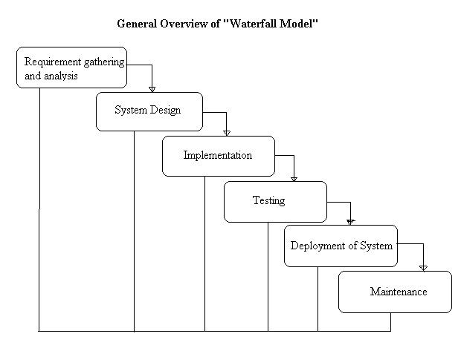

**Strengths**

Minimizes planning overhead since it can be done up front.

Structure minimizes wasted effort, so it works well for technically weak or inexperienced staff.

**Weaknesses**

Inflexible

Only the final phase produces a non-documentation deliverable.

Backing up to address mistakes is difficult.

# **CHAPTER FOUR:**

# **RESULTS AND DISCUSSIONS**

# 4.1: Output

The Chatbot system proved to be working efficiently, as it generates responses immediately after the user submits/sends his request. Presenting the data processed by a computer-based information system in an attractive and usable form has become very essential these days‟ success and acceptance of a system to some extent depends on good presentation.

Therefore, system analyst must know fully how to design output report in an attractive way. Many new output devices are being introduced in the market because of recent development in computer technology.

System analyst must be aware of these new technologies and try to use these new output devices if possible. Currently, excellent graphic displays are widely available. Speech output systems are also fast emerging.

* There are three main reasons why outputs from the computer are required. They are:

For communication to the persons concerned.

For re-input to the computer for being connected with other data and further processing.

For permanent storage.

# *Types of Output****:***

Outputs of a system can take different forms. The most common are reports, displays on screen, printed forms etc. the outputs also vary in terms of their contents, type of stationery. Frequency and timing etc. besides, due consideration also need to be given as to who will use the output and for what purpose. All these points must be kept in mind while designing outputs so that the objectives of the system are met in the best possible way.

-Outputs of a data-processing system can be placed into two categories:

-Application Output

-Operating Output

-Application Output

These are the outputs desired out of the system to meet its objectives.

These are of three types:

-Output as a basis for decision-making.

This type of output is generally required by management for decision-making purposes.

Output as a requirement to meet a functional objective.

Invoices, Excise Gate Pass, Purchase Orders are the examples of such output.

-Statutory outputs:

All organization is required to produce a certain amount of reports and forms as required by law.

-Operating Output

These outputs are mainly generated for use of EDP staff and give various indications as to how the system operates. System logs, error messages, status indicators etc. are the examples of such output. These types of output are not concerned for the users.

# *4.2: Characteristics observed:*

-The server doesn’t need to be rebooted often

-The software doesn’t change radically and in compatibly from release to release.

*-Features of MYSQL realized:*

* MySQL is a Database Management System.
* MySQL is a relational Database Management System.
* MySQL software is Open Source.
* The MySQL Database server is very fast, reliable, and easy to use.
* MySQL server works in client/server or embedded system environment.
* A large amount of contributed MySQL software is Available.

# *4.3: Risk Management*

Risk management is concerned with identifying risks and drawing up plans to minimize their effect on a project. A risk is a probability that some adverse Circumstance will occur. Project risks affect schedule or resources. Derive traceability information to assess requirements change impact, maximize information hiding in the design.

* Organizational Restructuring:

Prepare a briefing document for senior management showing how the project is making a very important contribution to the goals of the business.

Risk management includes four major parts as follows:

* Risk Identification
* Risk Analysis
* Risk Planning
* Risk Monitoring
* Risk Identification
* Technology risks.
* People risks.
* Organizational risks.
* Requirements risks.
* Estimation risks.
* Technology Risks:

The database used in the system cannot process as many transactions per second as expected. Software components that should be reused contain defects that limit their functionality.

People Risks:

It is impossible to recruit staff with the skills required. Key staff is ill and unavailable at critical times. Required training for staff is not available.

* Organizational Risks:

The organization is restructured so that different management is responsible for the project. Organizational financial problems force reductions in the project budget. Tools the code generated by CASE tools is inefficient. CASE tools cannot be integrated.

Requirements Risks:

Changes to requirements that require major design rework are proposed. Customers fail to understand the impact of requirements changes.

* Estimation Risks:

The time required to develop the software is underestimated. The rate of defect repair is underestimated. The size of the software is underestimated.

* Risk Analysis:

Assess the likelihood and consequences of these risks. Assess probability and seriousness of each risk. Probability may be very low, low, moderate, high or very high.

Risk effects might be catastrophic, serious, tolerable or insignificant.

* Risk Planning:

Draw up plans to avoid or minimize the effects of the risk. Consider each risk and develop a strategy to manage that risk.

* Risk Monitoring:

Assess each identified risks regularly to decide whether or not it is becoming less or more probable. Also assess whether the effects of the risk have changed. Each key risk should be discussed at management progress meetings.

# *4.4: Feasibility Study*

A feasibility study is a preliminary study undertaken to determine and document a project's viability. The results of this study are used to make a decision whether to proceed with the project, or table it. If it indeed leads to a project being approved, it will - before the real work of the proposed project starts - be used to ascertain the likelihood of the project's success.

It is an analysis of possible alternative solutions to a problem and a recommendation on the best alternative.

A feasibility study could be used to test a new working system, which could be used because:

The current system may no longer suit its purpose.

Technological advancement may have rendered the current system The business is expanding, allowing it to cope with extra work load.

Customers are complaining about the speed and quality of work the business it provides.

Competitors are now winning a big enough market share due to an effective integration of a computerized system.

* Operational Feasibility:

Operational Feasibility measures how well the solution will work in the organization and how will end user and management feels about the system. On studying the operational feasibility of the project, following could be derived:

* Aspects of Operational Feasibility

- Is the problem worth solving?

-Will the solution serve problem?

Computerized system for searching in the database will provide all the necessary information to employees and users in timely and efficient manner and in useful format.

* Technical Feasibility:

This involves questions such as whether the technology needed for the system exists, how difficult it will be to build, and whether the firm has enough experience using that technology. The assessment is based on an outline design of system requirements in terms of Input, Output, Fields, Programs, and Procedures. This can be qualified in terms of volumes of data, trends, frequency of updating, etc.

* Economic Feasibility:

This involves questions such as whether the firm can afford to build the system, whether its benefits should substantially exceed its costs, and whether the project has higher priority and profits than other projects that might use the same resources. This includes whether the project is in the condition to fulfil all the eligibility criteria and the responsibility of both sides in case there are two parties involved in performing any project.

# **CHAPTER FIVE:**

# **DISCUSSION**

# 5.1: Recommendation

I have developed this chatting system through applying my knowledge gained in class room, referring to certain books, browsing some sites and through the help of external and internal guides and using my own knowledge related to the subject itself. No project can be termed as perfect in real sense and there always remains scope for further improvement and so that helps to develop a new version. I am always eager to know some new points and validations related to the projects and which will give me more knowledge and help in creating a new version.

Through this project I took a step towards minimizing the gap between the students, using a common interaction platform using pup for discussion purpose. The present study contributes to the understanding of the effectiveness of online technical discussion forum in student improving their knowledge. In this the chatting facilities are provided to have the personal communication with friends. Technical online chatbot has positive effect on student interests and interaction; also learning, and normal chat when bored. By applying some technical improvements, the future scope will increase like distance learning and be able to compete with other online chatting systems currently in the market.

In some cases, where more flexibility is needed, the operation of a chatbot can be combined with human intervention. A Human-mediated chatbot utilizes human computation in at least one part of it. Fully autonomous chatbots may have weaknesses that can be overcome by staff working to integrate their intelligence into them. However, human computation lacks speed in information processing, and it is inevitable to cope with a vast amount of user requests.

Depending on the Permissions provided by the development platforms, chatbots can be divided into Open-source or Commercial, which we further discuss in Section. The classification of chatbots depends on the Communication channel that chatbots utilize, which can be text, voice, image, or all of them. The latest chatbots can now react to pictures, and aside from recognizing objects in the images, they can also comment on them and express their emotion.

I will develop this chatbot system through applying my knowledge gained in class room, referring to certain books, browsing some sites and through the help of external and internal guides, and using my own knowledge related to the subject itself. No project can be termed as perfect in real sense, and there always remains scope for further improvement and so that helps to develop a new version. I am always eager to know some new points and validations related to the project; which give us more knowledge and help us to create new versions.

# 5.2: Conclusion: -

For future enhancement, I may add much new functionality to the Chatbot System. We want to add more chats-responses and blog facility. In short I want to give power to the system, to be at levels with what other social networking sites have. At the same time, this chatbot system is used to overcome the entire problem which web users are facing currently in some organizations or institutions, and making complete atomization of manual system to computerized system. Although, this project is made for Small Scale communication; if I implement new technologies & features in this system, it will be able to compete with other online chatting applications.

# 

# APPENDIX A: ………………………………. REFERENCES

Lalwani, T., Bhalotia, S., Pal, A., Rathod, V., & Bisen, S. (2018). Implementation of a Chatbot System using AI and NLP. International Journal of Innovative Research in Computer Science & Technology (IJIRCST) Volume-6, Issue-3.

Sharma, V., Goyal, M., & Malik, D. (2017). An intelligent behaviour shown by chatbot system. International Journal of New Technology and Research, 3(4), 263312.

Clarizia, F., Colace, F., Lombardi, M., Pascale, F., & Santaniello, D. (2018, October). Chatbot: An education support system for student. In International Symposium on Cyberspace Safety and Security (pp. 291-302). Springer, Cham.

Amichai-Hamburger, Y., Wainapel, G., & Fox, S. (2002). “On the internet no one knows I'm an introvert": Extroversion, neuroticism, and internet interaction. CyberPsychology & Behavior, 5(2), 125- 128.

Anderson, T. (2004). Towards a theory of online learning. In T. Anderson, & F. Elloumi (Eds.), Theory and practice of online learning (pp. 33-60) Athabasca University Press.

Ranoliya, B. R., Raghuwanshi, N., & Singh, S. (2017, September). Chatbot for university related FAQs. In 2017 International Conference on Advances in Computing, Communications and Informatics (ICACCI) (pp. 1525-1530). IEEE.

Dahiya, M. (2017). A tool of conversation: Chatbot. International Journal of Computer Sciences and Engineering, 5(5), 158-161

Shawar, B. A., & Atwell, E. (2007, April). Different measurement metrics to evaluate a chatbot system. In Proceedings of the workshop on bridging the gap: Academic and industrial research in dialog technologies (pp. 89-96).

# APPENDIX B………………………. USER MANUAL

A user is required to start with a message to access the system. On the homepage, input data as per the fields given, which include. After sending a query, your data is now saved on my database, use your ‘username’ and ‘password’ to login to SmartChat Messenger and start enjoying chat services. During chat or even immediately after login, a user can change colors of the message box and also the texts; which is done by clicking on the “customize colors” button.

When done with chatting, a user clicks the logout button, and in order to login again, input the information required.

# APPENDIX C……………………………SAMPLES OF FIGURES AND TABLES

*A sample of the user messages and their chatbot-generated responses***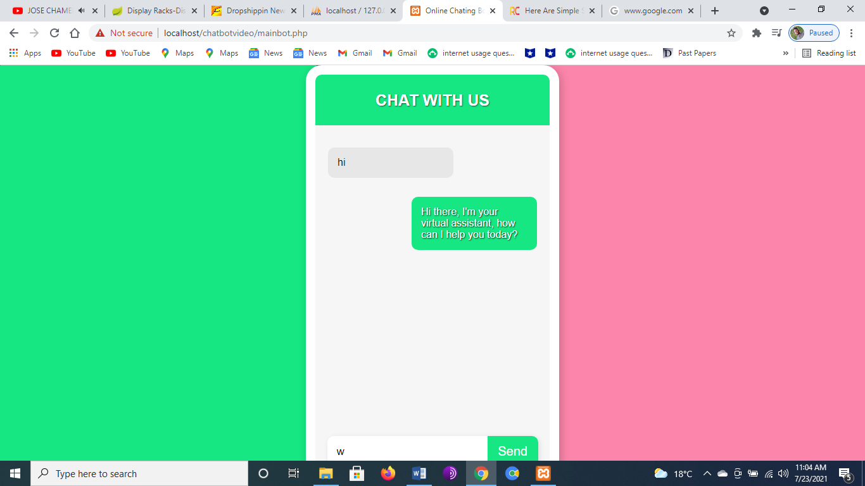 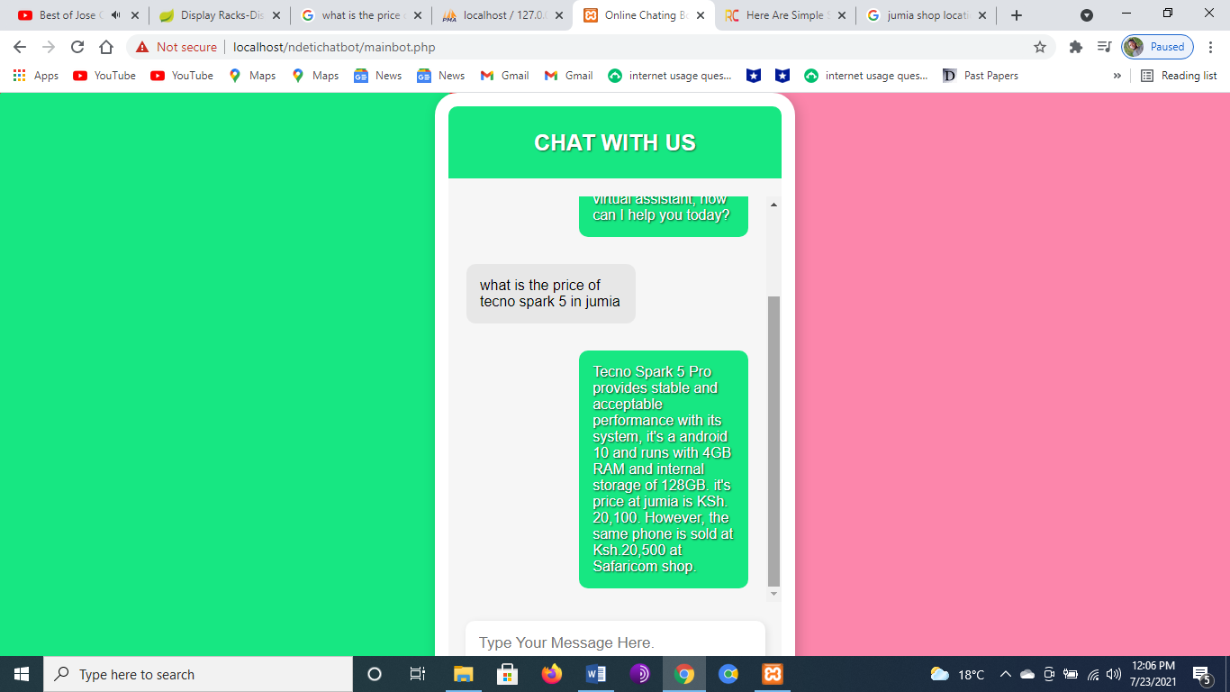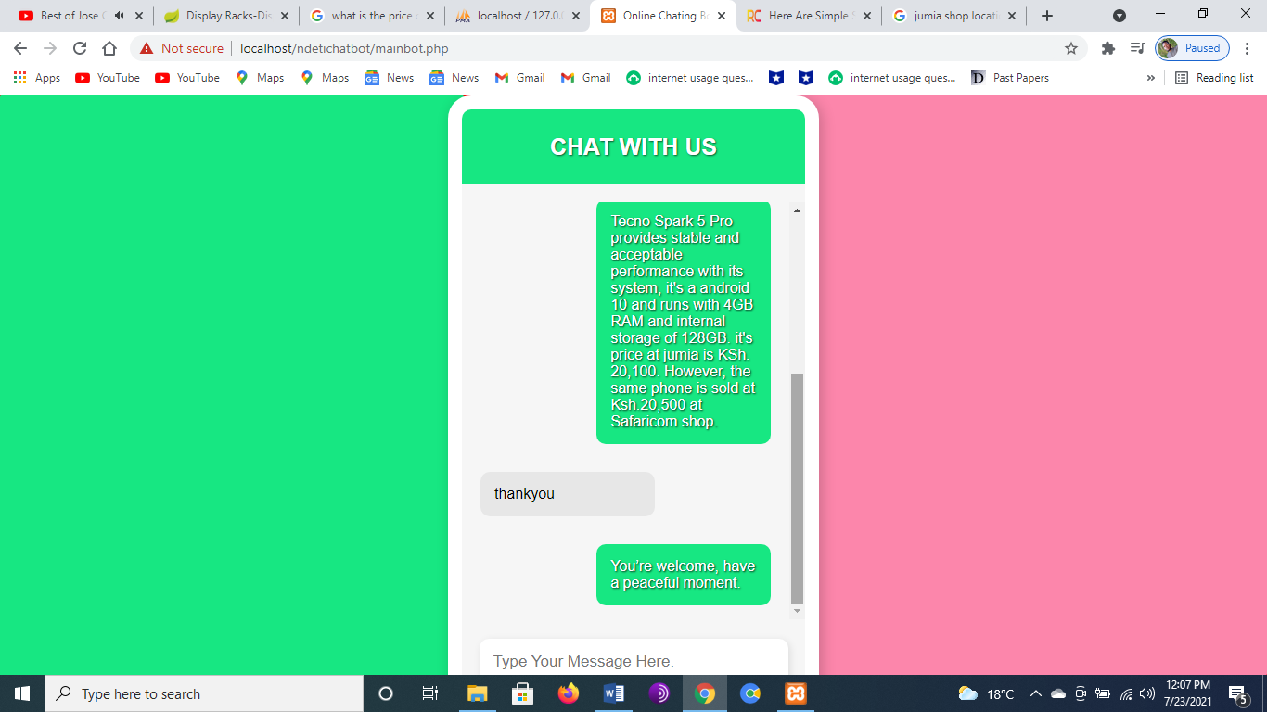**

# THE DATABASE DESIGN:

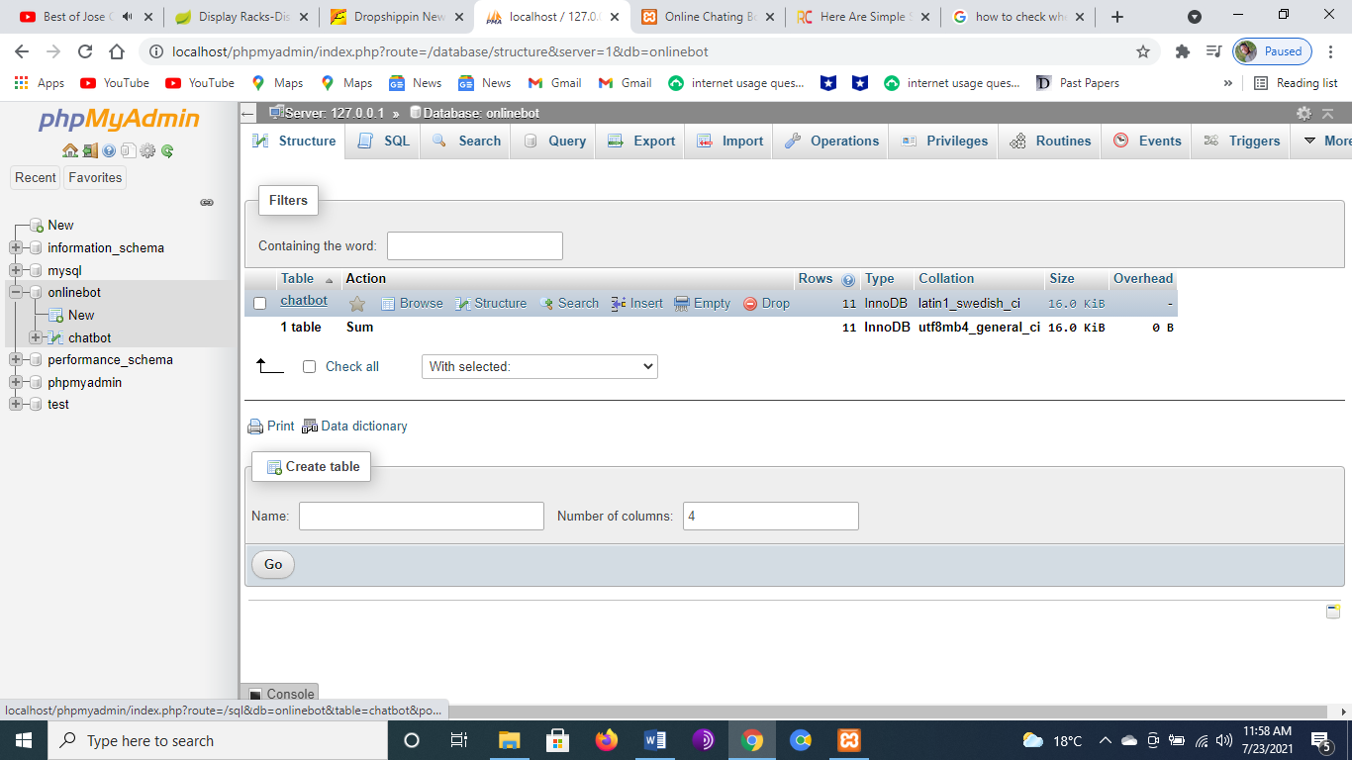

# *The onlinebot table for possible user-messages and their responses*

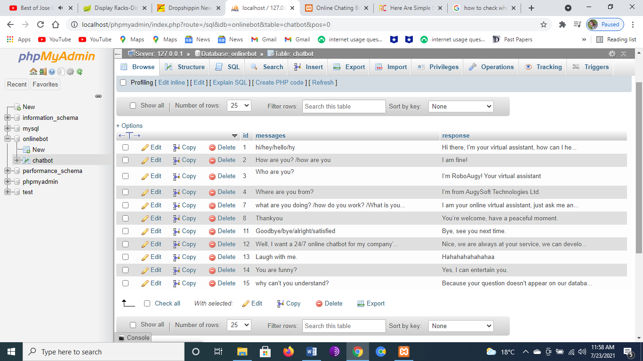

*An expandable database (where we can add any other possible user requests and the respective responses)* 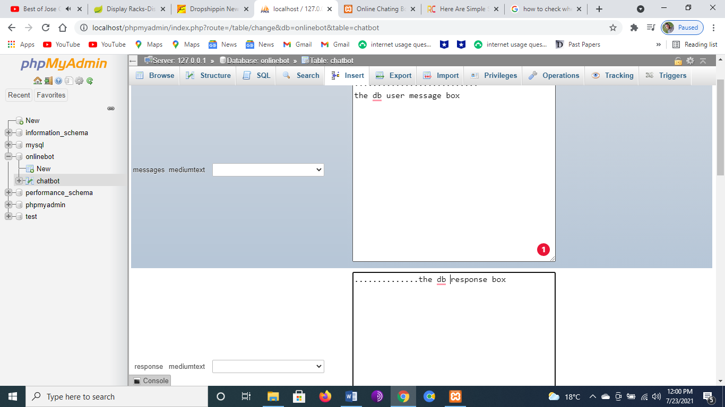

# SAMPLE CODES:

# *The main bot sample code:*

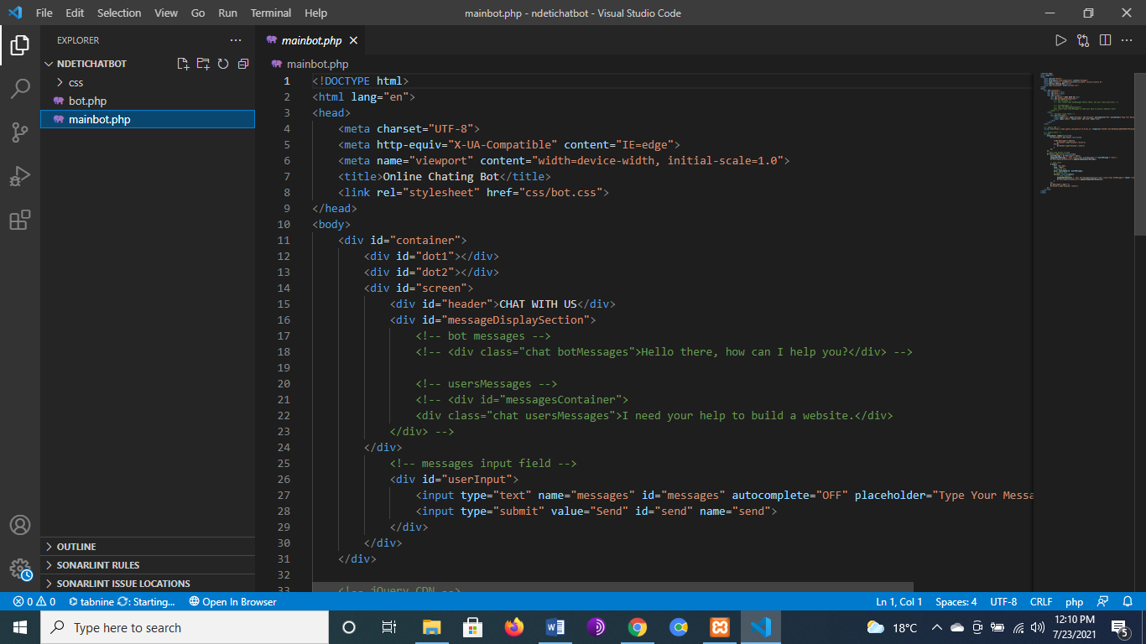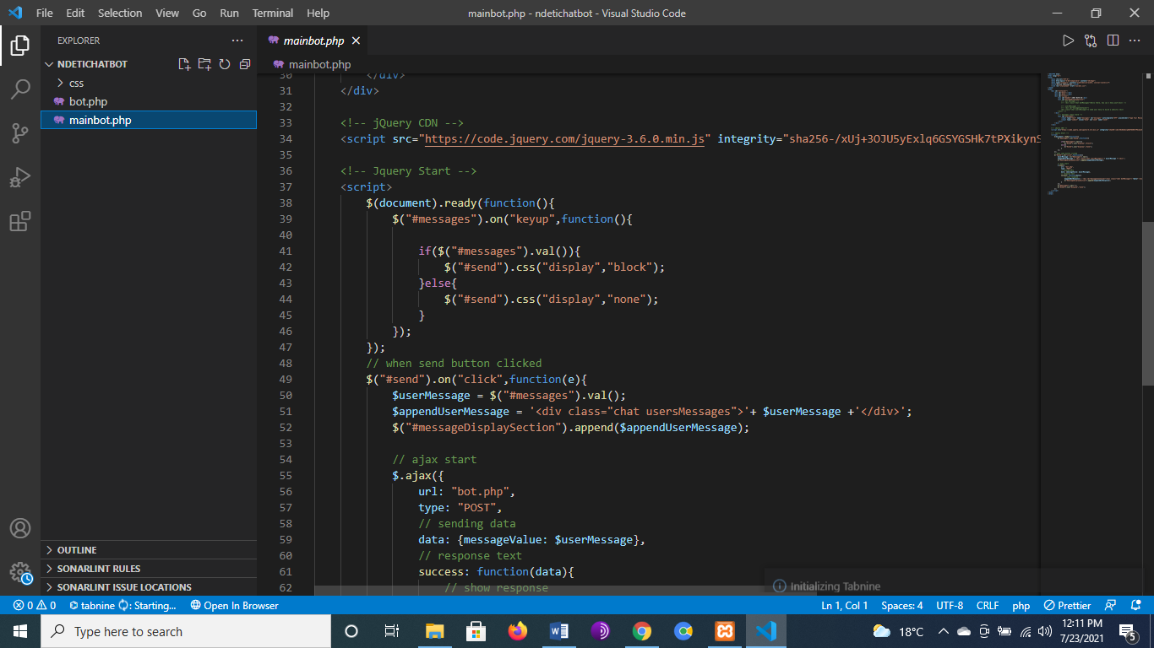

# *Database connection code (bot.php):*

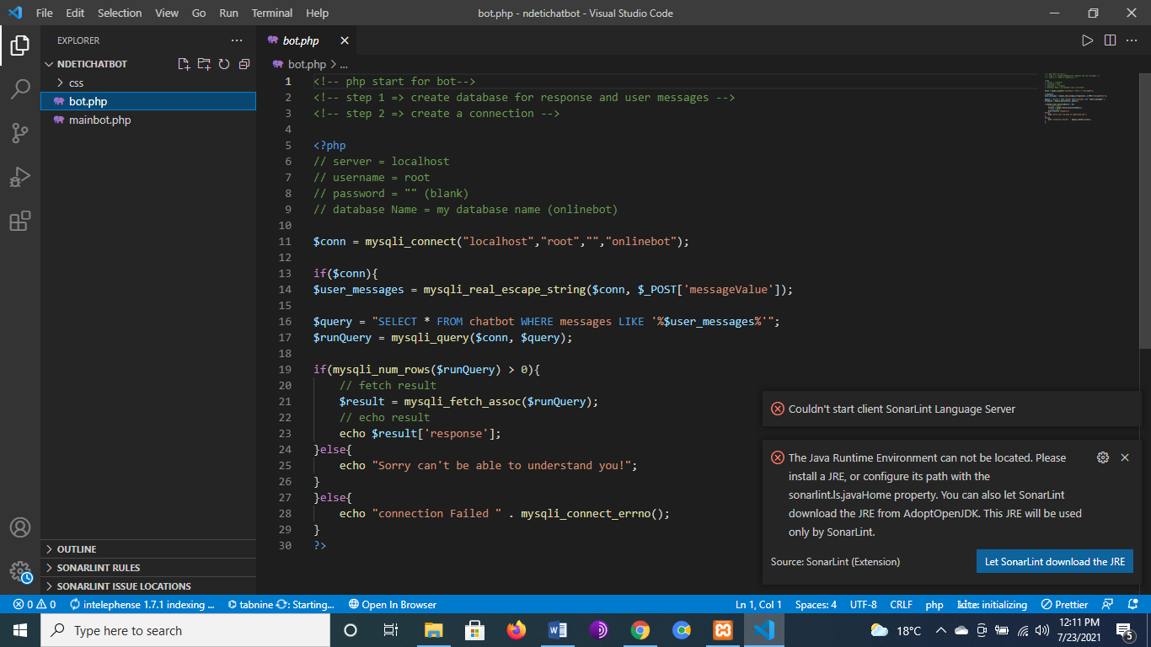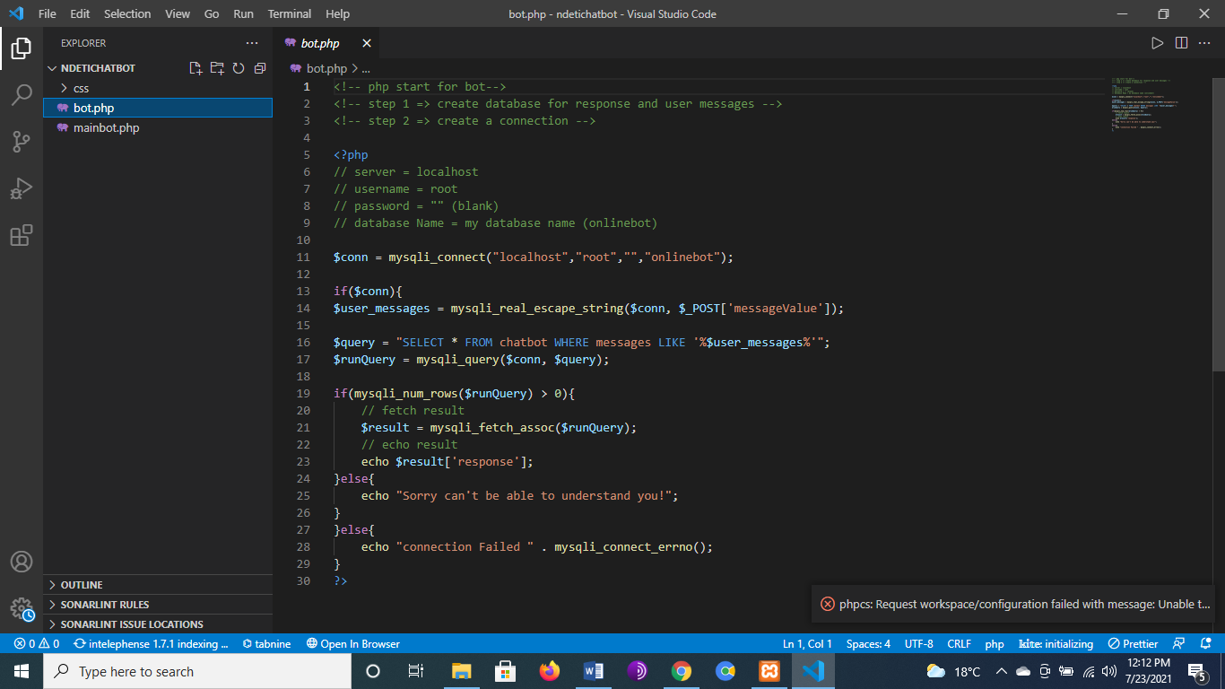

***The End***